Data Visualizations of Employment During COVID-19

Halleigh Kelchen, Krista Kreshpanji, & Marianne Guieb  
DATA-53000, Spring 2024

Data Visualization Lewis University

# Introduction

The COVID-19 pandemic has had a profound impact on various aspects of global health and economics, notably on employment, hospitalization, and mortality rates. These metrics not only serve as indicators of the pandemic’s severity but also help in understanding the broader societal impacts. During the pandemic, different sectors experienced varying degrees of disruption, influencing employment patterns significantly, while health outcomes like hospitalizations and deaths directly reflected the virus’s deadly toll. This report presents a comprehensive analysis of these data points through a series of detailed visualizations. The primary aim is to explore and identify potential relationships within the data that shed light on the pandemic’s multifaceted impact. By presenting these visualizations, we aim to provide clear and informative insights into how COVID-19 has shaped employment trends and health outcomes, enhancing our understanding of its long-lasting effects. The findings and visualizations will guide readers through the intricate dynamics of these variables during the unprecedented times of the COVID-19 pandemic.

# Data Description

As discussed in Section I, two datasets were combined consisting of New York City employment and COVID-19 hospitalizations and deaths in the city. The New York City employment dataset was filtered to only include monthly employment data from the end of February 2020 to the end of December 2022, and consists of 35 instances containing employment data for each industry [1]. Previously, this dataset has been used to look at trends in New York City employment over time and throughout different seasons. The COVID-19 dataset also contains 35 instances of data from hospitalizations and deaths due to COVID-19 during the pandemic [2]. This dataset has previously been used to examine trends in hospitalizations and deaths in New York City during the pandemic and combined with others to look at COVID-19 statistics country-wide. Table I. below identifies the 8 attributes and the 1 target variable, employment.

1. Data Attributes

| **Attribute** | **Type** | **Example Value** | **Description** |
| --- | --- | --- | --- |
| End of Month | Ordinal | 2/29/20 | The last day of the month |
| Industry | Categorical | Securities, Commodity Contracts, Investments | Type of employment industry |
| Total Nonfarm | Numeric | 4642.739 | Total number of nonfarm jobs |
| Total Private | Numeric | 4072.396 | Total number of private jobs |
| Hospitalized Count | Numeric | 1816 | Number of people hospitalized per day due to COVID |
| Hospitalized Count 7 day Average | Numeric | 1590 | Weekly average of people hospitalized due to COVID |
| Death Count | Numeric | 76 | Number of deaths per day due to COVID |
| Death Count 7 day Average | Numeric | 85 | Weekly average of deaths due to COVID |
| Borough | Categorical | Brooklyn | New York City borough location |
| Employment | Numeric | 193.53 | Number of people employed in a given industry |

# Methodology and results

Visualizations were primarily created using Python. Various packages such as Matplotlib and Seaborn were used. Additional data preprocessing was conducted using Pandas. In Fig 1, the correlation matrix illustrates the correlation between employment in various industries to covid metrics such as hospitalized count, 7 day average of hospitalized count, death count, and 7 day average of death count at the descent of the first major wave of COVID-19 from March 2020 to August 2020. The cutoff for the correlation coefficient was set at 0.9 to illustrate which industries were most affected by COVID-10. We instantly see that there’s a very strong correlation between covid hospitalization and Arts, Entertainment, and Recreation.

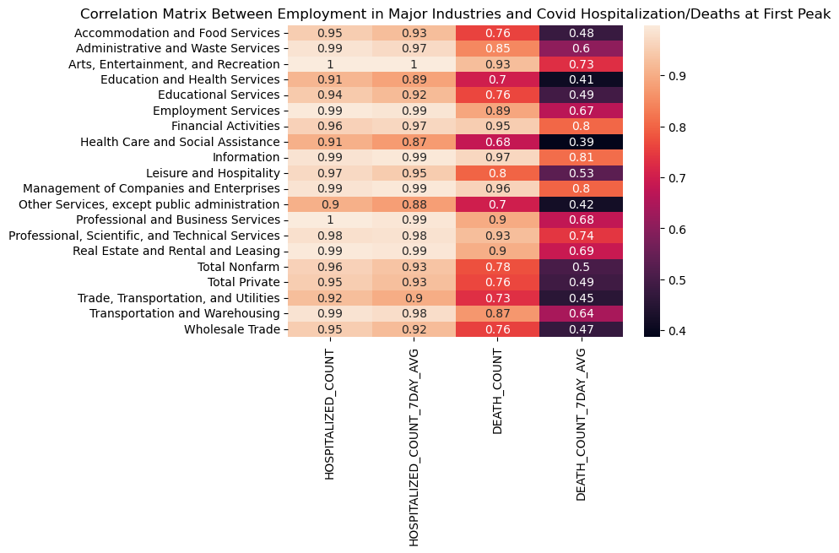

Fig. 1 Correlation Matrix

In Fig. 2, a visualization plotting total nonfarm employment and COVID-19 hospitalization. It’s plain to see that total nonfarm employment experienced a massive drop in employment at the descent of the first major wave of COVID-19. There was a small dip in employment around the second major wave of COVID-19. There were no significant changes in employment around the third major wave of COVID-19.

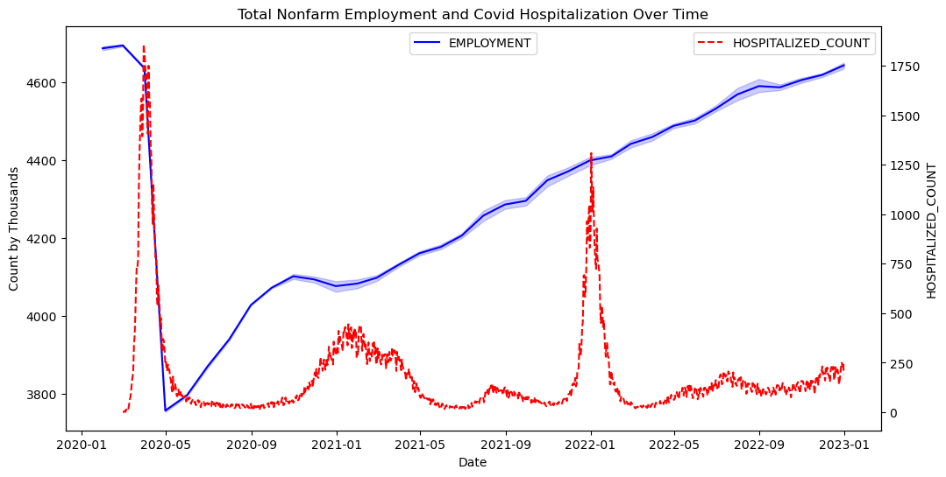

Fig. 2 Nonfarm Employment VS Hospitializations

Figure 3 features a pair plot designed to explore the relationships between Accommodations and Food Services, Health care and Social Assistance, Retail Trade, and manufacturing. This visualization includes scatter plots and histograms to reveal how employment levels across these sectors correlate and distribute. The scatter plot intersecting the “Accommodation and Food Services” row and the “Health Care and Social Assistance” column plots employment levels from these two sectors against each other. The clustering of data points indicates a positive correlation, suggesting that changes in employment in one sector are associated with similar changes in the other. Similarly, the scatter plot comparing Manufacturing and Retail Trade illustrates a positive correlation between the sectors suggesting a tight link possibly due to supply chain interdependencies, where shifts in manufacturing due to the Pandemic directly impact retail trade. The histograms show the distribution of employment levels within each sector. These plots give insight into the variability, skewness, and mean of employment levels within each sector during the pandemic. The histogram in the row and column of “Accommodation and Food Services” shows how employment in this sector was distributed over the period of the COVID-19 pandemic. These observations show that during this period, employment levels in these sectors exhibited strong positive correlations. This analysis highlights the interconnected nature of these industries, especially evident during the challenges posed by the pandemic.

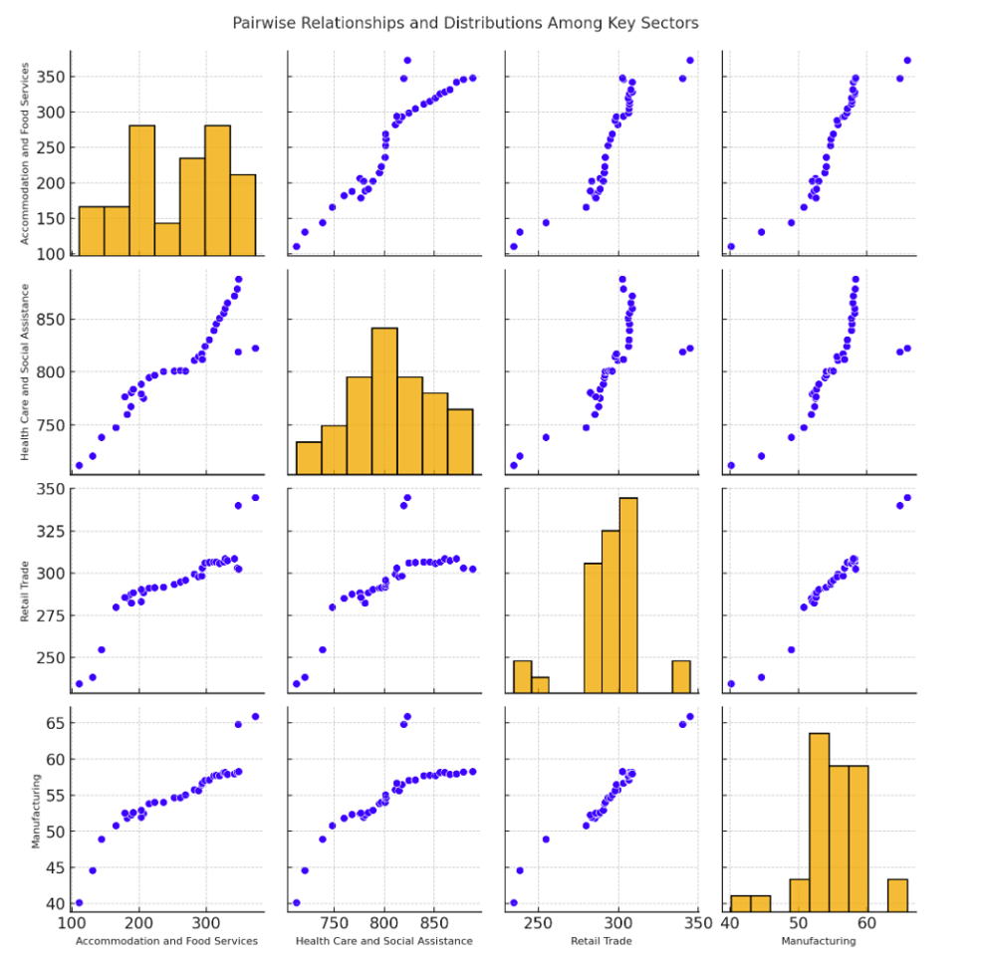

Fig. 3 Pairwise Relationship and Distributions Among Four Key Employment Sectors: Accommodation and Food Services, Health Care and Social Assistance, Retail Trade, and Manufacturing.

In Fig. 4, a bar chart is utilized to display the average employment levels across all employment-related sectors during COVID-19, highlighting the variability that reflects each sector’s vulnerability to the pandemic. Sectors such as Education and Health Services maintained higher employment levels due to the critical nature and constant demand for these services during the pandemic. Sectors likely impacted by lockdowns and restrictions, such as Accommodation and Food Services, display lower employment averages. The bar chart effectively condenses complex employment data into an accessible format that highlights disparities and trends, making it a valuable resource for analysis related to economic resilience during and post-COVID-19.

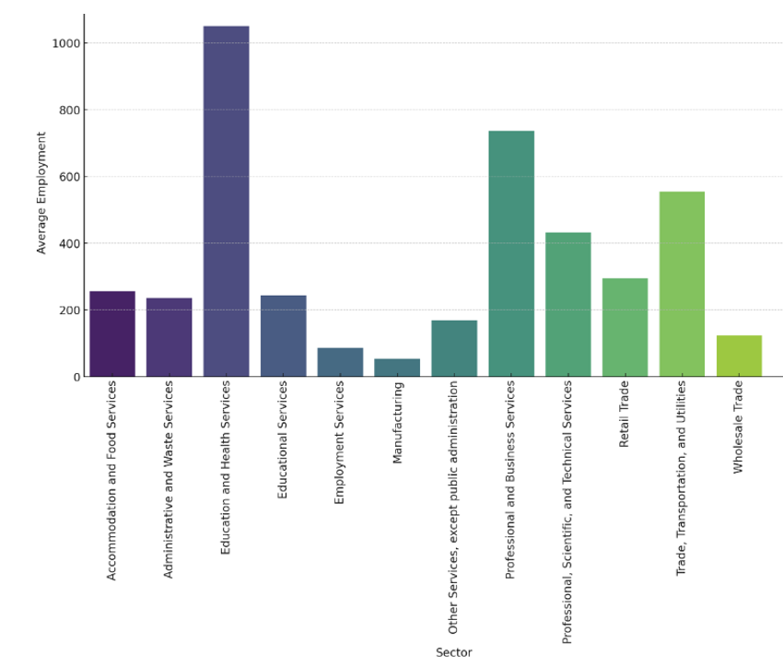

Fig. 4 Comparative Analysis of Employment Levels Across Sectors During COVID-19

In Fig. 5, a line plot was used to visualize the changes in employment of different industries throughout the pandemic.The visualization shows a dip in employment across several industries in May of 2020, which is consistent with the first wave of hospitalizations as shown in Fig. 2. Additonally, leisure, hospitality, and other services, not including public administration industries also show a small increase, followed by a secondary decrease from around the end of 2020, which in consistent with an increase in hospitalizations during this time as shown in Fig. 2. Additionally, employment in professional, scientific, and technical services stayed fairly consistent throughout the whole pandemic as shown in Fig. 5, which might sugesset these employees were considered ‘ essential workers’ during this time.

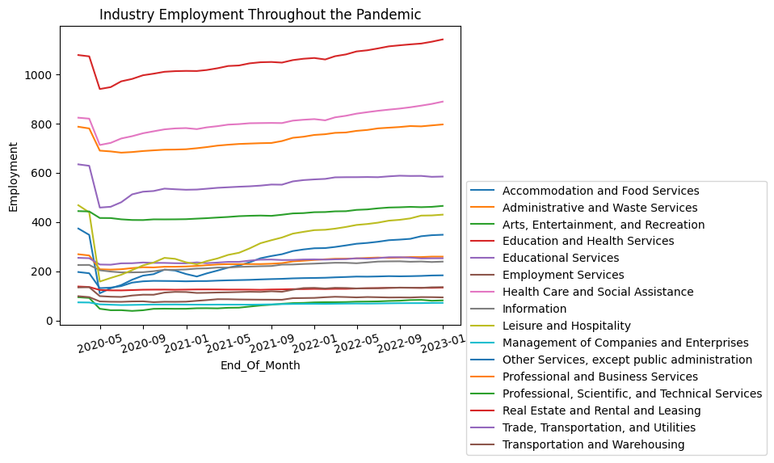

Fig. 5 Industry Employment Throughout the Pandemic

# Discussion

In Section III, we used different types of visualizations such as correlation matrices, bar graphs, and pairwise plots to visualize the effect of COVID-19 in different facets of employment in various industries. We created information visualizations in order to provide the audience with facts about the data, and some of the correlations, not necessarily causations. In Fig 1, we illustrated which industries were most correlated with COVID-19. In Fig 2, we see that covid hospitalizations had the strongest correlation with employment but only during the first wave of Covid. In Fig 3, we see the effect of COVID-19 across four major industries: Accommodation and Food Services; Health Care and Social Assistance; Retail Trade; and Manufacturing. In Fig 4, we see employment levels across various industries using a bar chart.

By visualizing different aspects of employment, we can see how different industries may have been affected by COVID-19. In this report, we learned several things about our data. We learned that COVID-19 had the largest impact on employment during the first wave. The subsequent waves had less and less impact on employment. We also learned that COVID-19 had a broad impact on employment across different sectors.

# Conclusions

In this report, employment and COVID-19 data from New York City were used to create visualizations and examine trends with different employment industries and the effect the pandemic had on them. With the visualization, industries most heavily affected by COVID-19 were identified, such as accommodation and food services, administrative and waste services, professional and business services, etc.

# Contributions

For this report, Halleigh Kelchen provided the New York Seasonally Adjusted dataset. She created Fig. 5 with description, and wrote the data description, conclusion, and references. Krista Kreshpanj provided the NYC Health dataset covering hospitalization and death rates. She wrote the introduction section of the report and created Figures 3 and 4, as well as wrote the descriptions for those figures. Marianne Guieb conducted the data cleaning on both datasets as well as joining the datasets using Python. Additionally, she created Fig 1 and Fig 2 as well as wrote the descriptions of Fig 1 and Fig 2 in the Methods and Results Section. She also wrote the Discussions Section.

##### References

[1] *New York City seasonally adjusted employment*. NYC Open Data. (n.d.). https://data.cityofnewyork.us/City-Government/New-York-City-Seasonally-Adjusted-Employment/5hjv-bjbv/data

[2] NYC Health. (n.d.). *Covid-19: Data*. COVID-19: Latest Data - NYC Health. https://www.nyc.gov/site/doh/covid/covid-19-data.page